|  |  |  |
| --- | --- | --- |
|  | **Weekly Team Task Report** | **#7** |

|  |  |  |  |  |  |  |  |  |
| --- | --- | --- | --- | --- | --- | --- | --- | --- |
| Team: GeoLearn | | | | | | **Date: 3/3/2020** | | |
| **Project Title: Improving elementary education with custom online enironmental science lectures** | | | | | | | | |
|  | **Samuel Prassse**  Present  On-time |  | **Kaitlyn Grubb**  Present  On-time |  | **Tyler Pehringer**  Present  On-time | |  | **Joshus Tenakhongva**  Present  On-time |

### Recent Meetings:

* General Team Meeting
* Sponsor Meeting (Tues, Thurs)

### TASKS COMPLETED since last meeting:

|  |  |  |  |
| --- | --- | --- | --- |
| **Task Title: Design Review 2** | **Task Initiation:** 2/18 | **Orig. Due Date: 2/28** | **Status:** Completed |
| **Who (%): Team (100%)** | | | |
| **Description: The team will be preparing and presenting our second Design Review to the Capstone faculty. Because of the stage we are in with our project, we will be able to showcase our website and database on AWS, and our slide creation methods as the “meat” of the presentation.** | | | |
| **Expected Outcome: An excellent presentation that will blow the rest of the class away.** | | | |

### This week’s Tasks: Work plan for coming week

|  |  |  |  |
| --- | --- | --- | --- |
| **Task Title: Full Prototype Demo** | **Task Initiation:** 3/3 | **Orig. Due Date: 3/4** | **Status:** In Progress |
| **Who (%): Samuel (25%), Kaitlyn (25%), Tyler (25%), Joshus (25%)** | | | |
| **Description: The team will demonstrate all implementation of all core functions of the product as a coherent solution satisfying all core use cases. We will schedule a meeting time with our mentor for the following week to demonstrate our product.** | | | |
| **Expected Outcome: Full implementation of our Alpha prototype.** | | | |

|  |  |  |  |
| --- | --- | --- | --- |
| **Task Title: Implement new slideshow templates** | **Task Initiation:** 3/3 | **Orig. Due Date: 3/13** | **Status:** In Progress |
| **Who (%): Samuel (25%), Kaitlyn (25%), Tyler (25%), Joshus (25%)** | | | |
| **Description: The team will utilize the templates given to us by our sponsor and implement them into the website by creating a skeleton template for them and populating them with geospecific data.** | | | |
| **Expected Outcome: Add land use change and climate change presentations to project.** | | | |

|  |  |  |  |
| --- | --- | --- | --- |
| **Task Title: Continue website design** | **Task Initiation:** 3/3 | **Orig. Due Date: 3/13** | **Status:** In Progress |
| **Who (%): Tyler (100%)** | | | |
| **Description: Tyler will continue to develop the design of the website through meetings with Dr. Doughty and Roo.** | | | |
| **Expected Outcome: A sleek website that conforms to the sponsor’s specifications.** | | | |

|  |  |  |  |
| --- | --- | --- | --- |
| **Task Title: Pull more data from earth engine** | **Task Initiation:** 3/3 | **Orig. Due Date: 3/13** | **Status:** In Progress |
| **Who (%): Samuel (75%), Joshus (25%)** | | | |
| **Description: Samuel and Joshus will work on gathering more data from earth engine with the help of Dr, Doughty. He will be sending us certain code to implement into the slideshow presentations.** | | | |
| **Expected Outcome: Complete the final two slideshow presentation templates.** | | | |

### Upcoming Tasks: Planning

|  |  |  |
| --- | --- | --- |
| **Task Title: Software Testing Plan** | **Who (%): Team (100%)** | **Rough Due Date: 3/13** |
| **Description: Ensuring that our project's implementation exhibits the necessary functional and non-functional characteristics.** | | |

|  |  |  |
| --- | --- | --- |
| **Task Title: Peer Eval 2** | **Who (%): Team (100%)** | **Rough Due Date: 3/13** |
| **Description: Submit peer evaluations to Fabio by Friday the 13th** | | |

### Other Problems / Other Issues:

* Dobble
* Time spent on the project

**Github:**

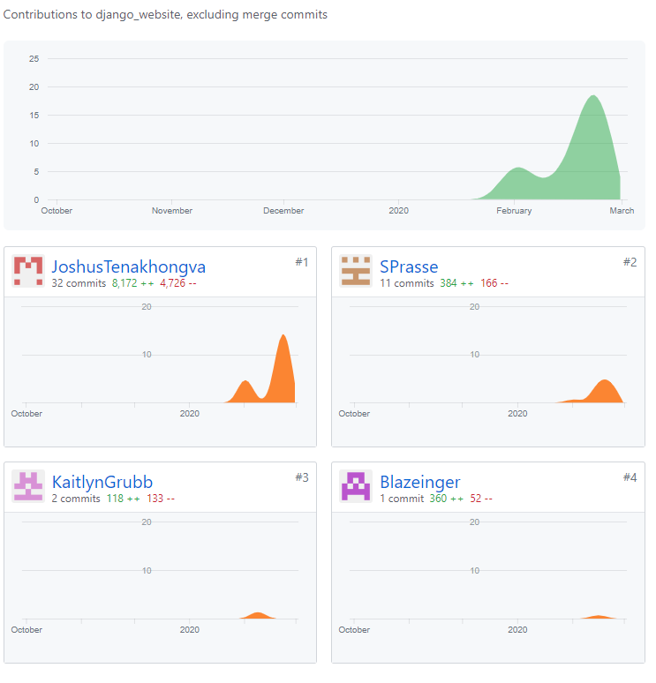

**Schedule:** 